Letter Management System 2.0

System Design Document(SDD)

Prepared by:
Felix Morales Pareja

Table of Contents

- System Architecture & Technology Stack
2.1 Technical Environment & Containerization
2.2 Primary Libraries Used

- Security & Authentication
2.1 Error Handling & Logging Matrix

- Data Model & Schema
3.1 Entity-Relationship Diagram(ERD)
3.2 Tables Description

- Folder Structure

- API Route Specification
5.1 Authentication Endpoints
5.2 Letter & Routing Endpoints
5.3 Assignment & Endorsement Endpoints
5.4 Webhooks & Integration Endpoints

- UI/UX Component & Wireframe Map
6.1 Layout Shell
6.2 Main Workspace Pages
- Testing Requirements
7.1 API Testing (Postman/Insomnia)
7.2 Frontend Testing (React UI/UX)

- Deployment Guide
8.1 Test Server Deployment
8.2 Production Server Deployment

- System Architecture & Technology Stack
LMS 2.0 uses a modern, separated client-server design. It is packaged using Docker so it runs the same way everywhere.

- Frontend: React.js with Vite. Styled beautifully using Tailwind CSS.
- Backend API: Powered by Node.js with Express.js. This server handles all the business rules, security, and webhooks.
- Database & Core CMS: Uses Directus Headless CMS (using SQLite or MariaDB). Directus automatically handles basic database tasks and user accounts.
- External Integrations:
- Telegram API: A Webhook in the backend sends instant chat alerts when letters move.
- Legacy System: The frontend connects to an older PHP API(172.18.162.84) to read old historical records.

  - Technical Environment & Containerization
- Operating System (OS): The local development environment operates on Windows, while the production server uses an Ubuntu Linux LXC/VM Container environment hosted on Proxmox.
- Docker Engine: The entire application stack is containerized using Docker and orchestrated via Docker Compose.
- Container Architecture: The system runs three primary, interconnected containers simultaneously:
- lms-frontend: Hosts the React/Vite application.
- lms-backend: Hosts the Node.js/Express API.
- lms-directus: Hosts the Directus CMS and SQLite database.
1.2 Container Diagram
The Diagram below shows how the client browser, external APIs, and Docker containers communicate.
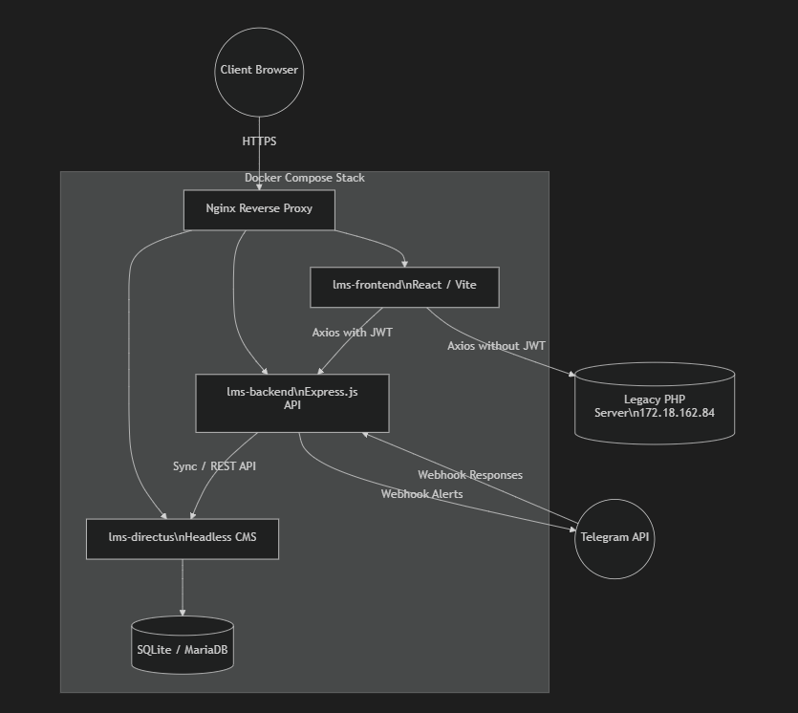

2.2 Primary Libraries Used
- Frontend Libraries:
- react-router-dom: For smooth, single-page page navigation without reloading.
- axios: For managing API requests and injecting authorization headers.
- lucide-react: For rendering clean, scalable vector icons.
- tailwindcss: For rapid and responsive UI styling.
- Backend Libraries:
- express: The core web server and routing framework.
- sequelize: For object-relational mapping (ORM) and database queries.
- sqlite3 / mysql2: Database connection drivers.
- pdf-lib: For creating, editing, and merging PDF attachments securely.
- multer: For handling multipart form data and file uploads.
- argon2: For strong, modern password hashing.

- Security & Authentication
Security is build into every layer of LMS 2.0 using tokens

- Stateless Login: Users log in through Directus. The system saves a secure Session Token (directus_auth) in the browser.
- Frontend Interceptor: A global Axios Interceptor in React automatically attaches the Authorization: Bearer <token> to every API request. It safely skips the old PHP legacy server to avoid CORS errors.
- Backend Protection: The Express.js server uses an ensureAuthenticated middleware. It blocks anyone trying to access private data without a valid token by returning a 401 Unauthorized error.
- Protected Routes: The React router hides private pages from users who are not logged in.

2.1 Error Handling & Logging Matrix
This matrix explains how system errors handled and logged.

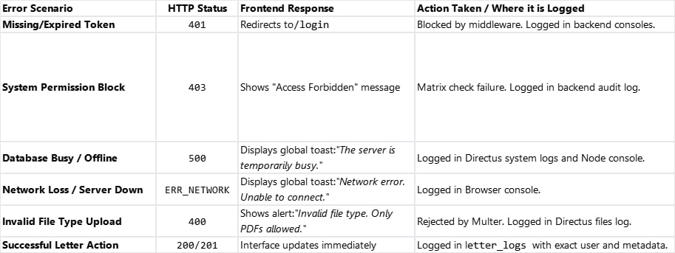

- Data Models & Schema
These are the data collections configured within Directus that store all system information

3.1 Entity-Relationship Diagram(ERD)
This database diagram maps the primary entities and relationships inside our system.
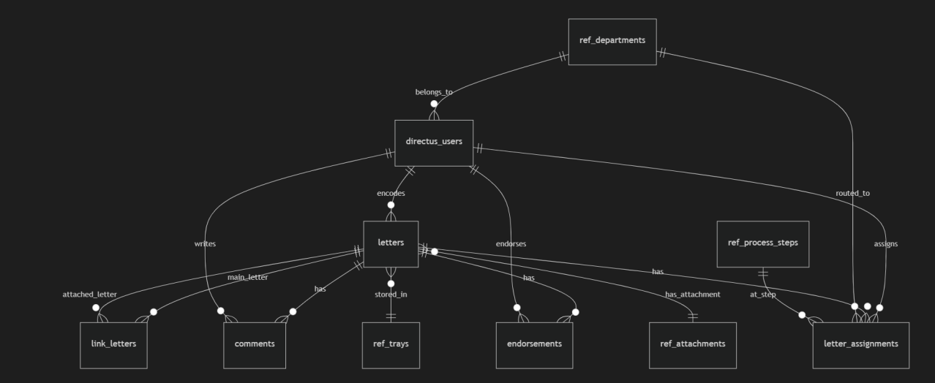

3.2 Tables Description
1.) Reference Collections(Lookup Tables)
- ref_letter_kinds: Types or categories of letters.
- ref_statuses: Current state of a letter (e.g., Pending, Processing, Done).
- ref_departments: List of organizational teams and departments.
- ref_process_steps: Milestones in the workflow.
- ref_trays: Real-world physical tray locations.

2.) Core Collections(Lookup Tables)
- letters: The main records containing letter details.
- directus_users: System user accounts.
- directus_roles: System roles and access levels.
- role_permissions: Access matrix rules that control who can view or edit pages.
- system_pages: List of accessible pages in the system.
- person: Directory of senders and endorsers.
- ref_attachments: Scanned files, PDFs, and documents.

3.) Tracking & Logs Tables
- letter_assignments: Connects a letter to a department and a process step.
- letter_logs: A permanent history of all user actions.
- comments: Discussion threads on a specific letter.
- endorsements: Notes and routing details created when a letter is forwarded.
- link_letters: Connects related letters together (e.g., matching a Letter to its Response).

- Folder Structure
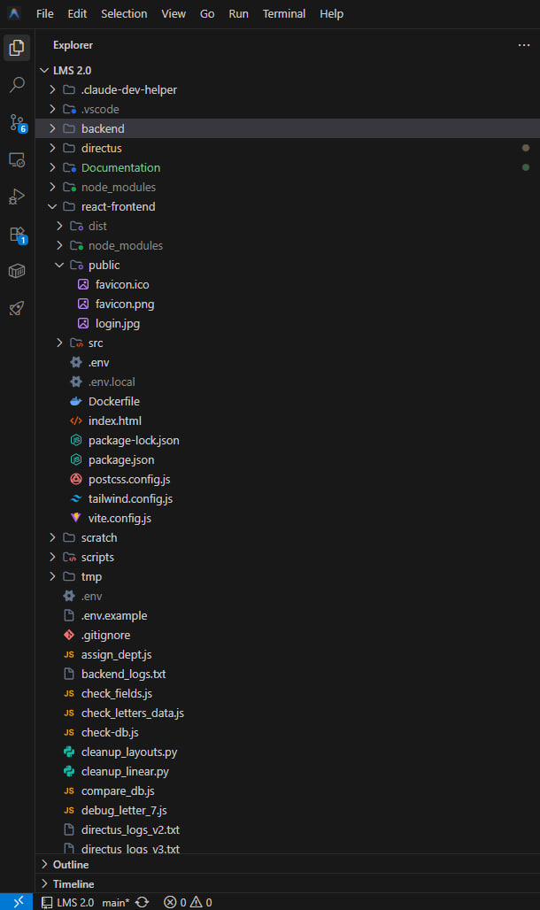

- API Route Specification
This section detail the primary backend API endpoints running on LMS 2.0

5.1 Authentication Endpoints
- POST /auth/login (Public)
- Description: Takes email and password. Authenticates user against Directus.
- Response: 200 OK with Directus Access Token, or 401 Unauthorized.

5.2 Letter & Routing Endpoints
- GET /api/letters (Protected)
- Description: Fetch all letters. Filterable by status, sender, and role permissions.
- Response: 200 OK with JSON array of letters.
- POST /api/letters (Protected)
- Description: Creates a new letter in the system and generates a unique tracking ID.
- Response: 201 Created with the new letter details.
- GET /api/letters/trash-count (Protected)
- Description: Returns the total count of deleted letters.
- Response: 200 OK - { "count": X }.

5.3 Assignment & Endorsement Endpoints
- GET /api/endorsements/count (Protected)
- Description: Returns count of pending endorsements for the user's active department.
- Response: 200 OK - { "count": X }.
- POST /api/endorsements (Protected)
- Description: Forwards a letter to a new department with added workflow notes.
- Response: 201 Created.
5.4 Webhooks & Integration Endpoints
- POST /api/telegram/webhook (Public)
- Description: Receives incoming update notifications from the Telegram Bot API.
- Response: 200 OK.
- GET http://172.18.162.84/api/letters_detailed.php (External)
- Description: Directly queries the legacy system database for older letters.
- Response: 200 OK with legacy JSON dataset.

- UI/UX Component & Wireframe Map
LMS 2.0 uses a highly structured UI/UX component mapping to maintain layout consistency.

6.1 Layout Shell
- Sidebar Component(Sidebar.jsx)
Displays collapsible navigation links based on role permissions.

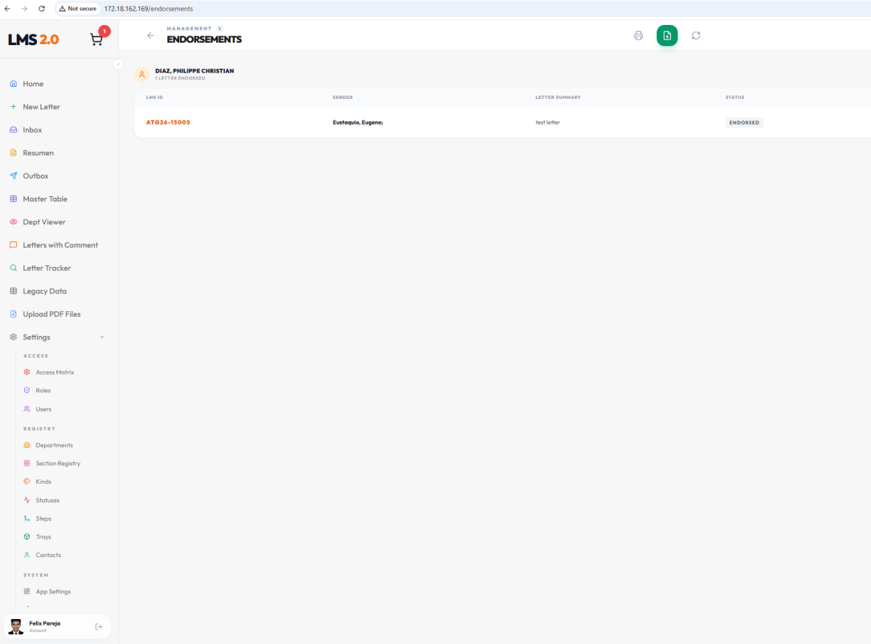
- Navbar Component: Shows the current user profile, active department name, and the Logout button.
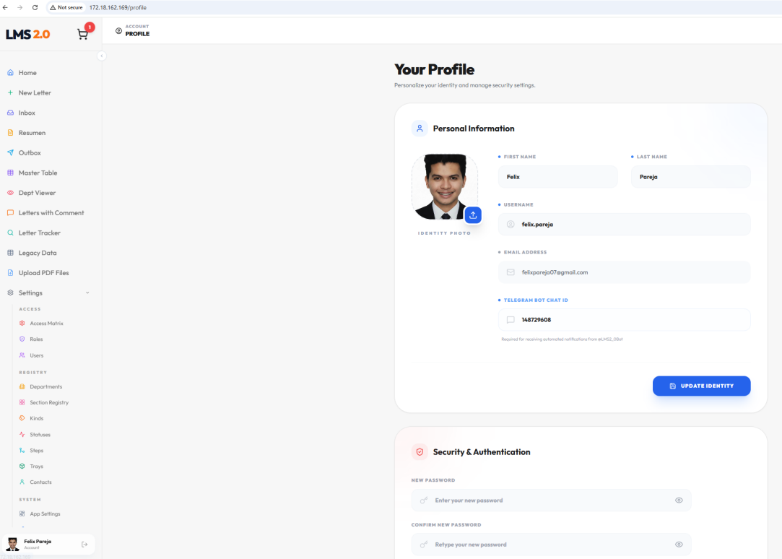

6.2 Main Workspace Pages

- New Letter (NewLetter.jsx)
Used by Encoders and Admins to input details
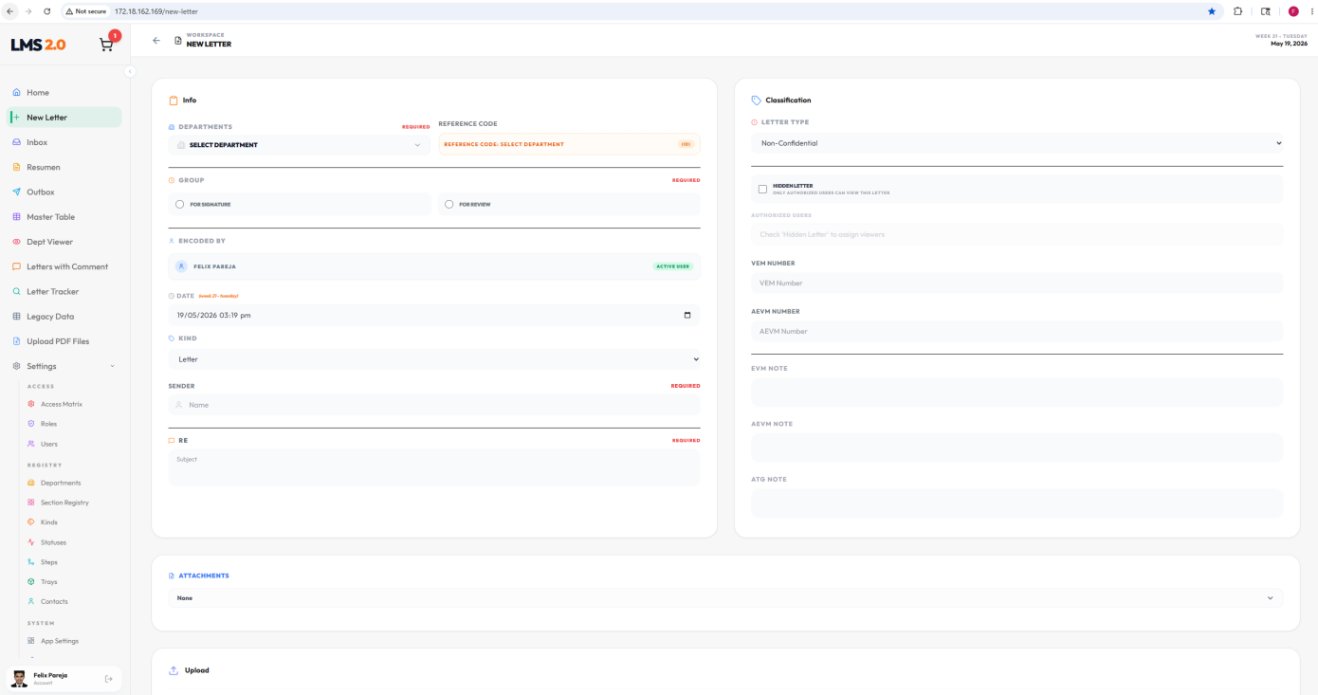

- Guest (GuestSendLetter.jsx)
Guests can securely fill out a form and upload PDF file

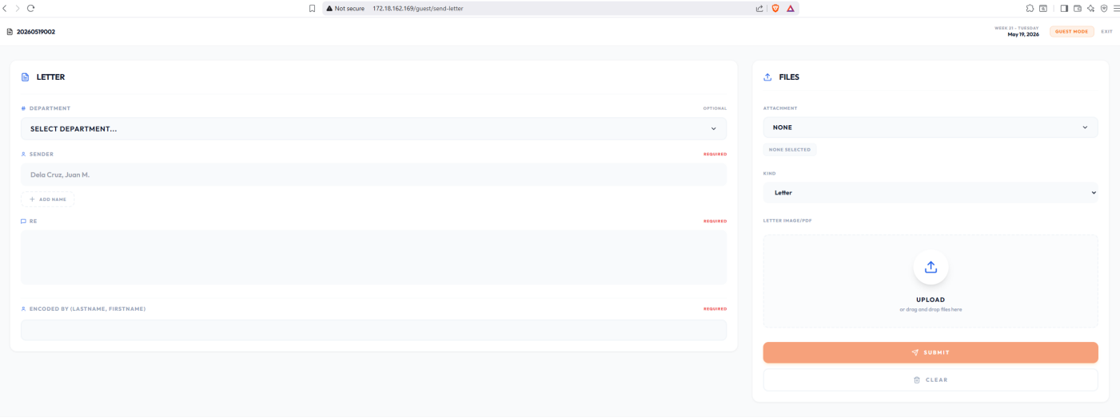

- Unified Inbox (Inbox.jsx)
The daily tasks dashboard for standard department staff. It displays a dense table grid of active letters currently assigned to the logged-in user's department
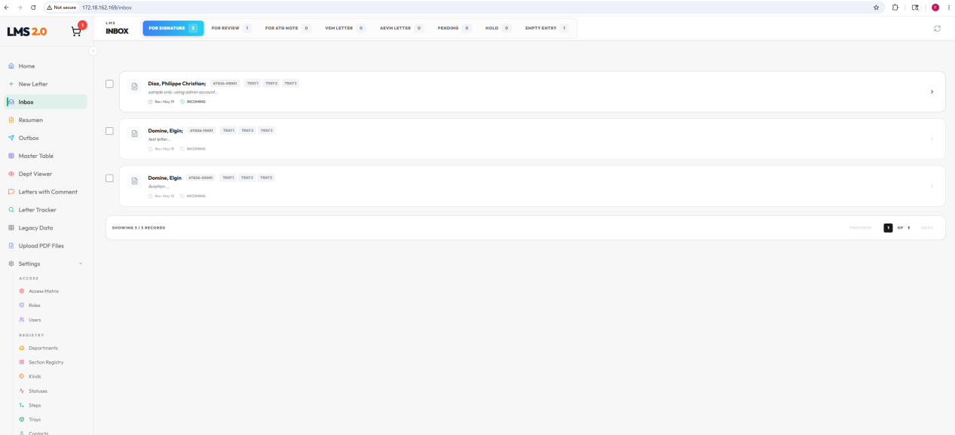

- Resumen Page (ResumenPage.jsx)
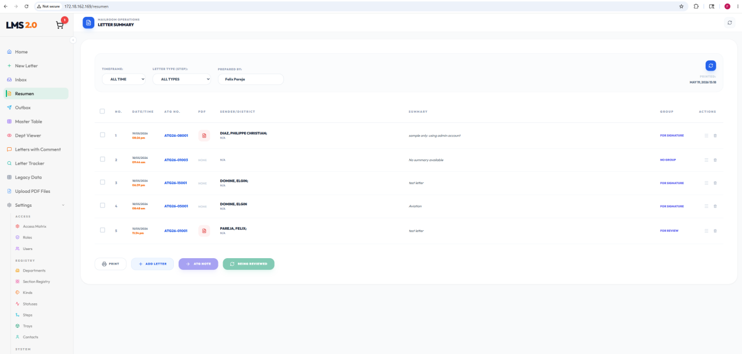

- Master Table (MasterTable.jsx)
It lets managers search, filter, and track the status of any document across the entire organization in a unified spreadsheet-style table.

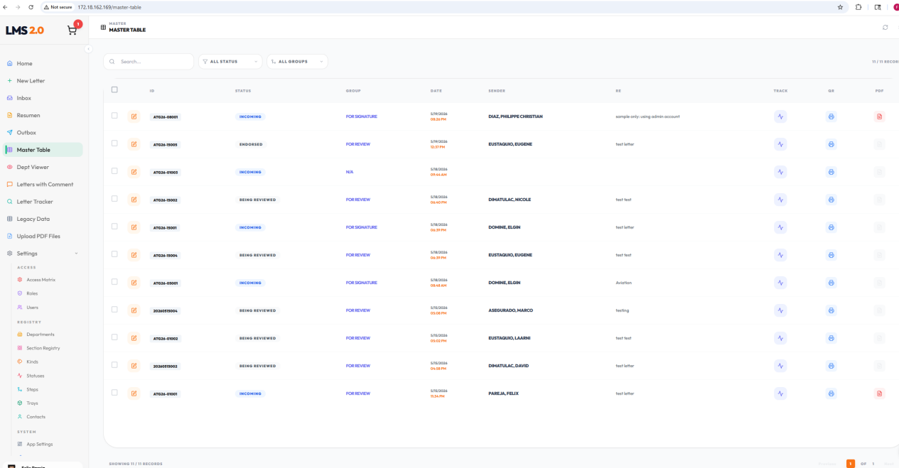
Tracking Window
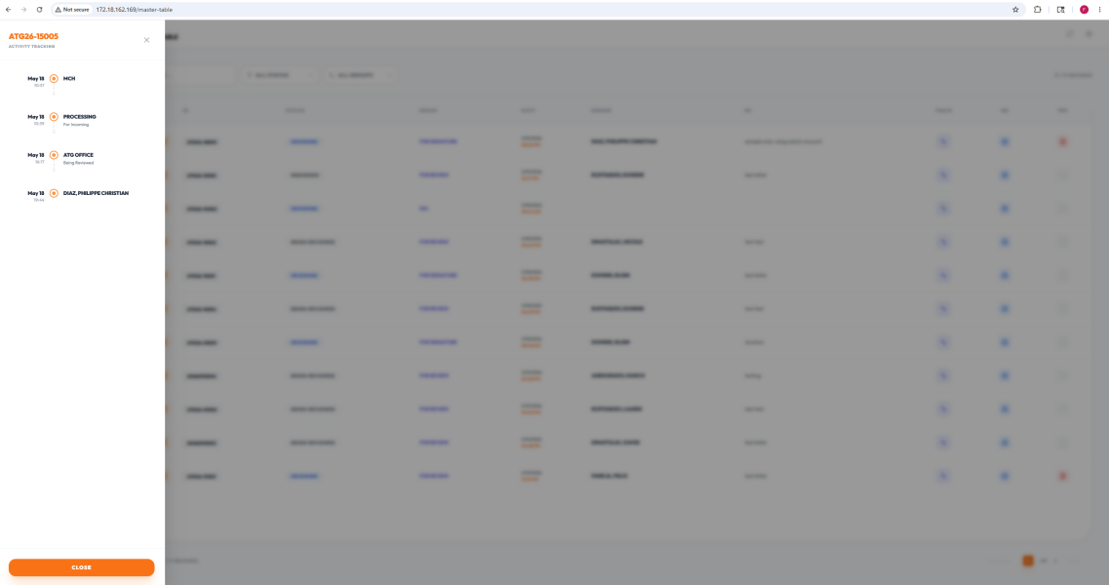

- Letter Tracker
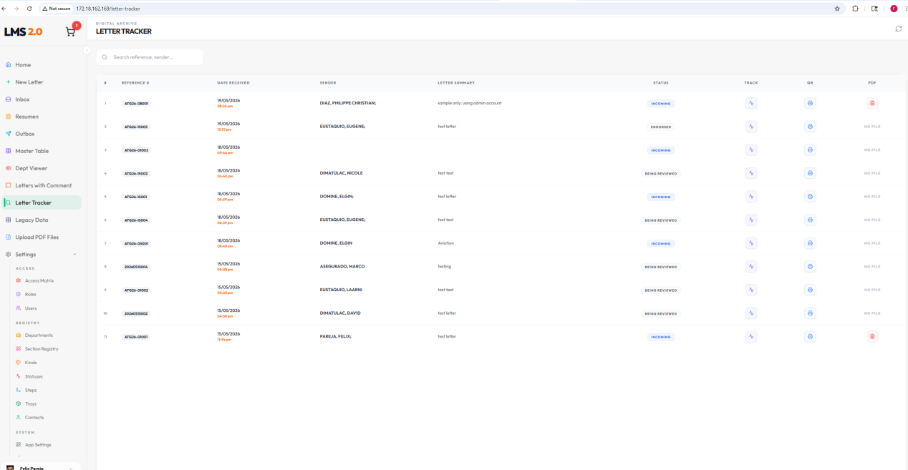

- Access Matrix
It lists all system routes (Setup, Master Table, Inboxes) and maps out which roles (Admin, VIP, Staff) are allowed to view, create, edit, delete, or perform special actions on those routes
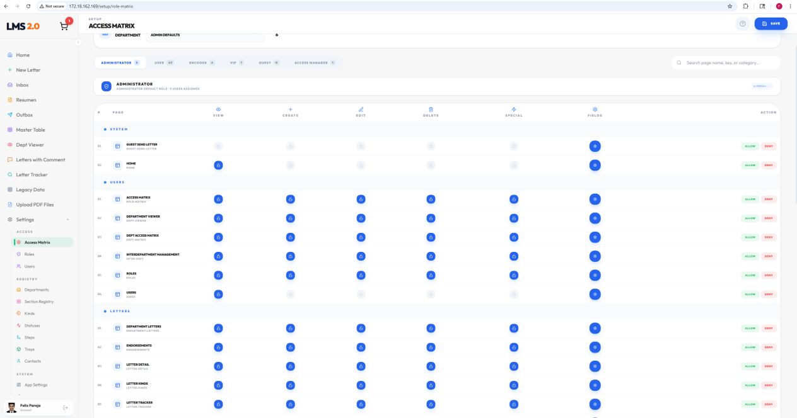

- Users Page
The administrative directory interface used to manage system accounts
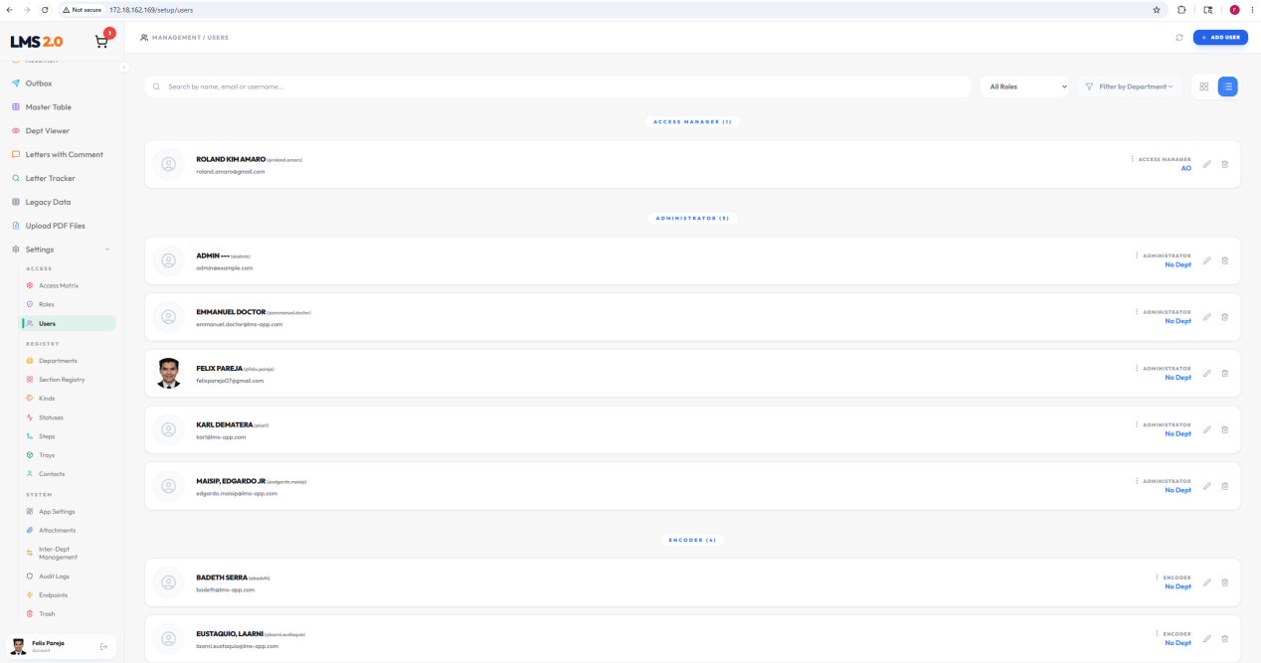

- Technical Integration & Testing

To ensure the system is secure and works perfectly, testing is divided into three main areas.

7.1 API Testing (Postman/Insomnia)
Postman-style tests to ensure your ensureAuthenticated middleware blocks unauthorized users and properly manages the legacy PHP CORS connections.

🛡️Security & Middleware
- Verify the ensureAuthenticated middleware by sending a GET request to /api/letters without token. It must immidiately return a 401 Unathorized error.
- Send a request with an invalid or expired Bearer token to ensure it is properly blocked.
- Verify that public endpoints like /api/auth/login and Telegram Webhooks(api/telegram/webhook) remain accessible without a token.
📊Data Integrity & Relational Queries
- Test the Directus login endpoint to ensure it correcly issues a valid JWT access token upon login.
- Verify that the Unified Inbox API returns deeply nested JSON data(e.g., Letter details + Assignment status + Process Step names) correctly joined from multiple tables.
- Test cross-origin requests to the legacy PHP system(172.18.162.84) to confirm the frontend interceptor safely skips the token to prevent CORS preflight errors.

7.2 Frontend Testing (React UI/UX)
Testing the visual interface and user experience to ensure it is smooth and responsive.

📱Responsiveness & Layouts
- Test the Sidebar and main dashboard on a mobile screen size to ensure menus collapse smoothly and content remains readable.
- Verify that switching between different layout styles(e.g., Minimalist, Grid) successfully updates the visual theme without breaking page elements.
🔄 Statement Management & Real-time Updates
- Verify that changing a letter’s status(e.g., from “Pending” to “Incoming”) instantly updates the UI in the Unified Inbox without requiring a full page reload.
- Trigger a network failure (e.g., turn off the backend) and verify that the global error handler displays a clean, user-friendly “Toast” notification (e.g., “Network Error”) instead of crashing the app.
- Deployment Guide
The system uses Docker Compose. This makes it easy to install or deploy anywhere.

8.1 Test Server Deployment
Use this server to test new features and check user workflows before going live.

- Prerequisites: Install Node.js, Docker Desktop, and Git on the machine.
- Clone: Open the terminal and clone the repository using Git.
- Dependency Build: Run npm run install-all to download all required packages.
- Database Stack: Run docker-compose up -d to start the Directus database container.
- Launch Application: Run npm run dev to start the frontend and backend servers.
- Verification: Access the active testing environment at http://172.18.162.169.

8.2 Production Server Deployment
Use this server for the live, actual system used by users.

- Prepare Server: Create an Ubuntu LXC or VM on Proxmox. Allocate at least 2GB RAM and 2 CPUs.
- Install Docker: Install Docker and Docker Compose on the Ubuntu server.
- Clone Code: Clone the project repository onto the server.
- Network Config: Update the .env and docker-compose.yml files with the production IP: 172.18.121.96.
- Start System: Run docker-compose up --build -d to build and run all containers (Frontend, Backend, and Directus) in the background.
- Verification: Access the production environment at http://172.18.121.96.

